Getting started with Hoopla Digital

Step 1: Register for a free Hoopla Digital account
Either go to hoopladigital.com and click the get started button or download the free Hoopla Digital app.

Step 2: Enter your information
Enter your email address and create a new password. Review Hoopla Digital’s terms and conditions and click on the Agree button. Once your account is verified, you will need this email address and password to sign into Hoopla Digital.

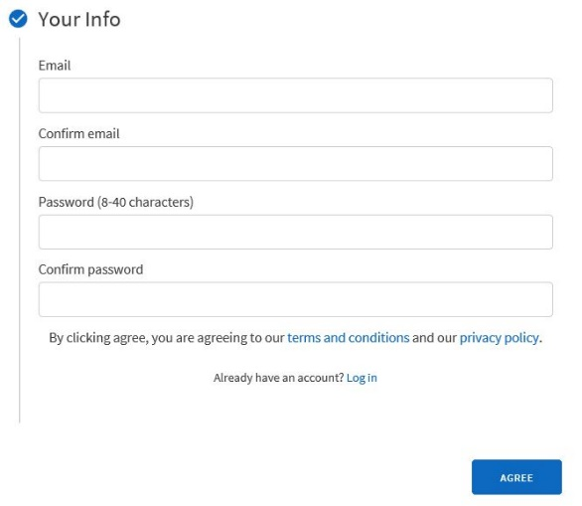

3: Choose your library
Either choose your library from a list of local libraries or use the search box for a specific library. Click on the Next button to continue registering.

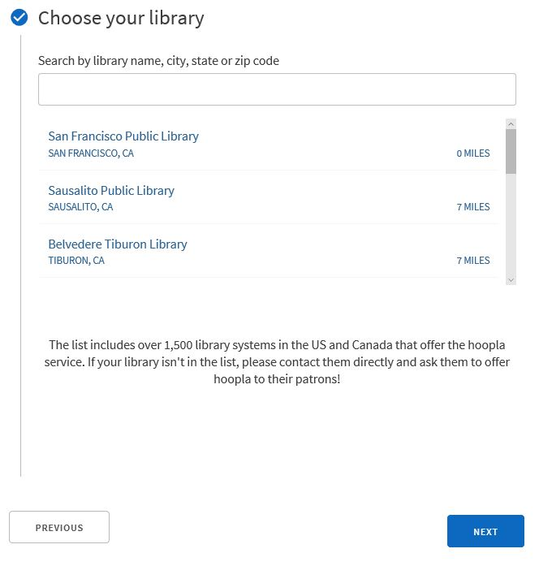

Step 4: Enter your library card number.
Type your library card number, without spaces, in the box. Click on the Sign Me Up button. If your library card number ever changer, you will need to update your Hoopla Digital account at Settings > Library > Library Card Number.

Step 5: Start using Hoopla Digital
You’re done! You will now be automatically signed into Hoopla Digital. If you need to sign into Hoopla Digital in the future, use the address and password you registered in Step 2.

Additional information:
When you next check your email, you’ll find a welcome message from Hoopla Digital, describing the library subscription.
If you ever replace your library card number, remember to update it in your Hoopla Digital account settings

